**23rd Vasaloppet China, January 4th, 2025**

**TRAVEL PACKAGES FROM ORGANIZER**

|  |  |
| --- | --- |
| **4 DAYS TRIIP**  **Vasaloppet China race & Changchun local travel** | |
| Jan. 02, 2025 | 1. Arrive at Beijing Capital International Airport. 2. Go to Changchun. 3. Check into Hotel in Changchun. |
| Jan. 03, 2025 | 1. Have breakfast, lunch and dinner at the hotel. 2. Pick up race supplies, track test and visit 【Jingyuetan Snow Sculpture World】. 3. Visit ice light show at the 【New World Of Ice And Snow】. |
| Jan. 04, 2025 | 1. Have breakfast and lunch at the hotel. 2. Vasaloppet China 50km, 25km and 2km will start at the same time. 3. Have dinner at the Vasanight. |
| Jan. 05, 2025 | 1. Have breakfast at the hotel. 2. Visit landmark buildings in Changchun :   ①【Cultural Square】 (Manchurian State Capital Square)  ②【Geological Palace Museum 】(Puyi Palace)   1. Return trip. |

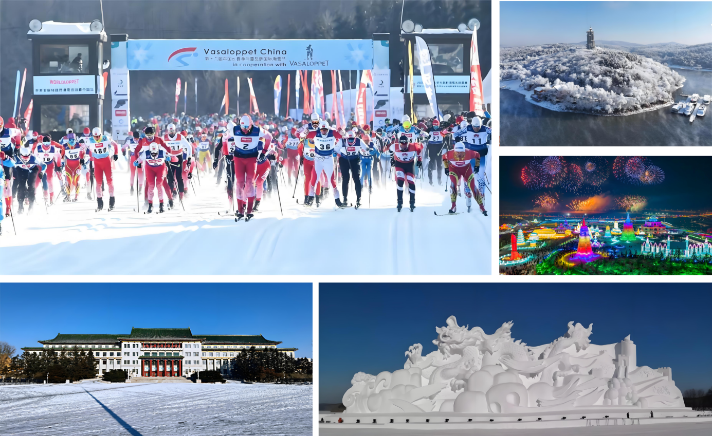

|  |  |
| --- | --- |
| **SIX DAYS TRIP**  **Vasaloppet China race & Changchun local travel & Shanghai travel** | |
| Jan. 02, 2025 | 1. Arrive at Beijing Capital International Airport. 2. Go to Changchun. 3. Check into Hotel in Changchun. |
| Jan. 03, 2025 | 1. Have breakfast, lunch and dinner at the hotel. 2. Pick up race supplies, track test and visit 【Jingyuetan Snow Sculpture World】. 3. Visit ice light show at the 【New World Of Ice And Snow】. |
| Jan. 04, 2025 | 1. Have breakfast and lunch at the hotel. 2. Vasaloppet China 50km, 25km and 2km will start at the same time. 3. Have dinner at the Vasanight. |
| Jan. 05, 2025 | 1. Have breakfast at the hotel. 2. Visit landmark buildings in Changchun :   ①【Cultural Square】 (Manchurian State Capital Square)  ②【Geological Palace Museum 】(Puyi Palace)   1. Have lunch at a local restaurant. 2. Go to Shanghai. 3. Check into hotel in Shanghai. 4. Have dinner at a local restaurant. |
| Jan. 06, 2025 | 1. Have breakfast at the hotel. 2. Visit 【Lujiazui Finance&Trade Zone】 and 【Shanghai Tower】. 3. Have lunch at a local restaurant. 4. Visit 【Nanjing Road】and 【The Bund】 5. Take a boat trip on the 【Huangpu River】 in the evening. 6. Have dinner at a local restaurant. |
| Jan. 07, 2025 | 1. Have breakfast at the hotel. 2. Visit 【Yu Garden】and 【City God Temple】. 3. Have lunch at a local restaurant. 4. Return trip. |

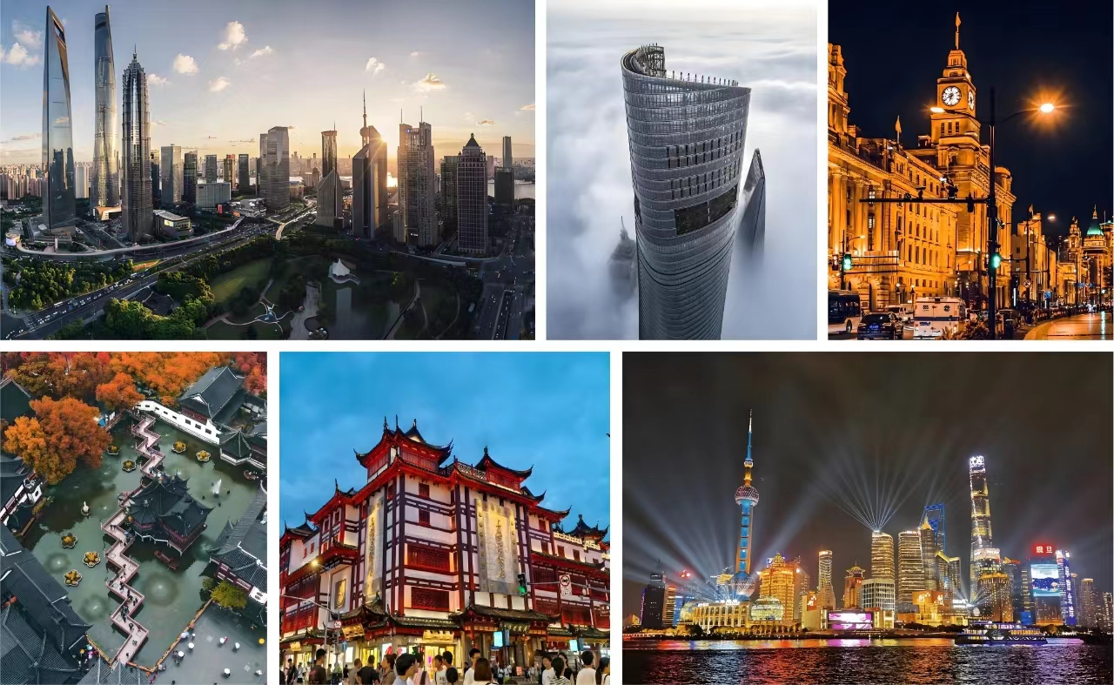

|  |  |
| --- | --- |
| **SEVEN DAYS TRIP**  **Vasaloppet China race & Changchun local travel & Beijing travel** | |
| Jan. 02, 2025 | 1. Arrive at Beijing Capital International Airport. 2. Go to Changchun. 3. Check into Hotel in Changchun. |
| Jan. 03, 2025 | 1. Have breakfast, lunch and dinner at the hotel. 2. Pick up race supplies, track test and visit 【Jingyuetan Snow Sculpture World】. 3. Visit ice light show at the 【New World Of Ice And Snow】. |
| Jan. 04, 2025 | 1. Have breakfast and lunch at the hotel. 2. Vasaloppet China 50km, 25km and 2km will start at the same time. 3. Have dinner at the Vasanight. |
| Jan. 05, 2025 | 1. Have breakfast at the hotel. 2. Visit landmark buildings in Changchun :   ①【Cultural Square】 (Manchurian State Capital Square)  ②【Geological Palace Museum 】(Puyi Palace)   1. Have lunch at a local restaurant. 2. Go to Beijing. 3. Check into hotel in Beijing. 4. Dinner at a local restaurant. |
| Jan. 06, 2025 | 1. Have breakfast at the hotel. 2. Visit the 【Forbidden City】 and 【Tian 'anmen Square】. 3. Have lunch at a local restaurant. 4. Visit 【Qianmen】 and 【Temple of Heaven】 in the afternoon. 5. Peking Duck for dinner. |
| Jan. 07, 2025 | 1. Have breakfast at the hotel. 2. Visit 【Badaling Great Wall】. 3. Light meal for lunch (bread, milk, sausage). 4. Chinese dumplings/fried dumpling for dinner. |
| Jan. 08, 2025 | 1. Have breakfast at the hotel. 2. Return trip. |

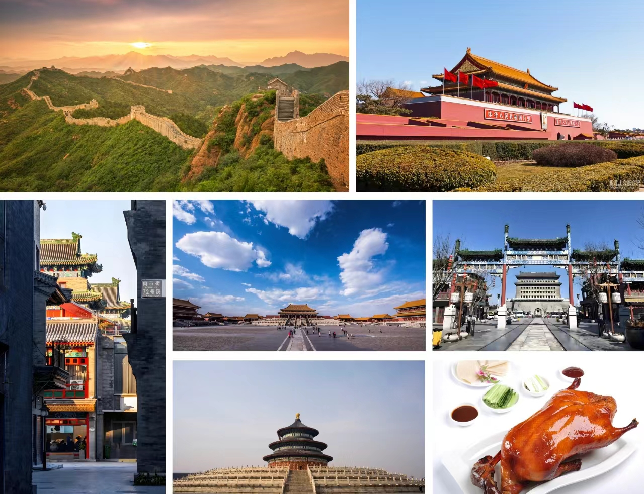

|  |  |
| --- | --- |
| **NINE DAYS TRIP**  **Vasaloppet China race & Changchun local travel & Shanghai + Beijing travel** | |
| Jan. 02, 2025 | 1. Arrive at Beijing Capital International Airport. 2. Go to Changchun. 3. Check into Hotel in Changchun. |
| Jan. 03, 2025 | 1. Have breakfast, lunch and dinner at the hotel. 2. Pick up race supplies, track test and visit 【Jingyuetan Snow Sculpture World】. 3. Visit ice light show at the 【New World Of Ice And Snow】. |
| Jan. 04, 2025 | 1. Have breakfast and lunch at the hotel. 2. Vasaloppet China 50km, 25km and 2km will start at the same time. 3. Have dinner at the Vasanight. |
| Jan. 05, 2025 | 1. Have breakfast at the hotel. 2. Visit landmark buildings in Changchun :   ①【Cultural Square】 (Manchurian State Capital Square)  ②【Geological Palace Museum 】(Puyi Palace)   1. Have lunch at a local restaurant. 2. Go to Shanghai. 3. Check into hotel in Shanghai. 4. Have dinner at a local restaurant. |
| Jan. 06, 2025 | 1. Have breakfast at the hotel. 2. Visit 【Lujiazui Finance&Trade Zone】 and 【Shanghai Tower】. 3. Have lunch at a local restaurant. 4. Visit 【Nanjing Road】and 【The Bund】 5. Take a boat trip on the 【Huangpu River】 in the evening. 6. Have dinner at a local restaurant. |
| Jan. 07, 2025 | 1. Have breakfast at the hotel. 2. Visit 【Yu Garden】and 【City God Temple】. 3. Have lunch at a local restaurant. 4. Go to Beijing. 5. Check into hotel in Beijing. 6. Dinner at a local restaurant. |
| Jan. 08, 2025 | 1. Have breakfast at the hotel. 2. Visit the 【Forbidden City】 and 【Tian 'anmen Square】. 3. Have lunch at a local restaurant. 4. Visit 【Qianmen】 and 【Temple of Heaven】 in the afternoon. 5. Peking Duck for dinner. |
| Jan. 09, 2025 | 1. Have breakfast at the hotel. 2. Visit 【Badaling Great Wall】. 3. Light meal for lunch (bread, milk, sausage). 4. Chinese dumplings/fried dumpling for dinner. |
| Jan. 10, 2025 | 1. Have breakfast at the hotel. 2. Return trip. |

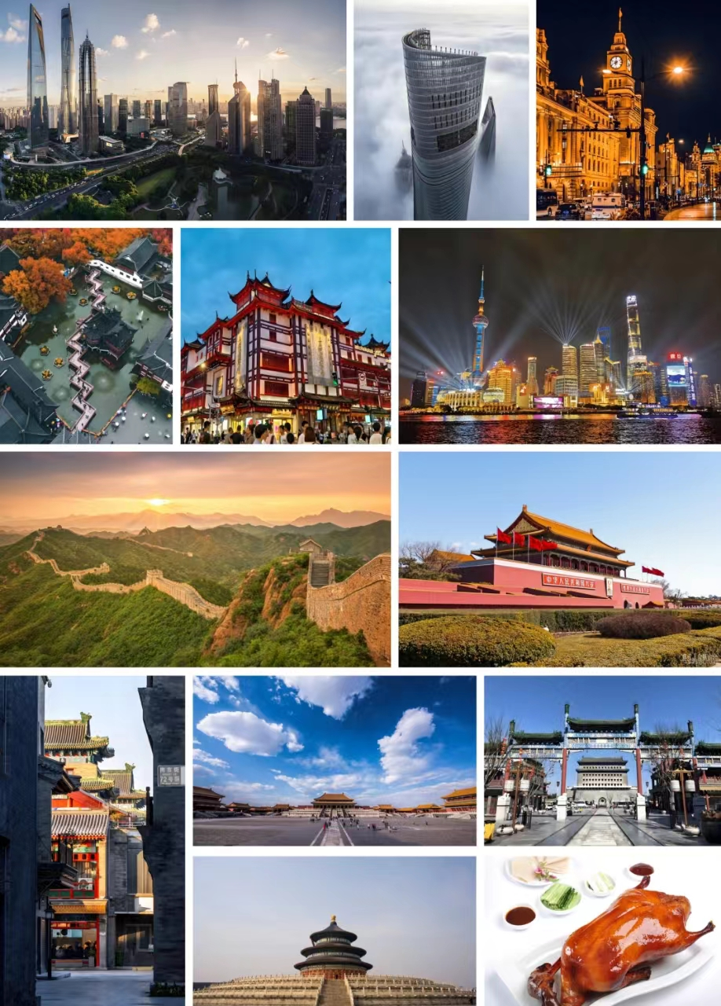

|  |  |
| --- | --- |
| **Race Category** | Type（**√**）after the option you wish to select |
| 0.3 KM: 100 CNY |  |
| 1.5 KM: 150 CNY |  |
| 6 KM: 200 CNY |  |
| 25 KM: 490 CNY |  |
| 50 KM: 750 CNY |  |
| **Package** | Type（**√**）after the option you wish to select |
| 4 DAYS: 2400 CNY |  |
| 6 DAYS: 5800 CNY |  |
| 7 DAYS: 6000 CNY |  |
| 9 DAYS: 9600 CNY |  |

|  |  |  |  |  |
| --- | --- | --- | --- | --- |
| **Hotel** | 5-Star  （single room） | 5-Star  （twin room） | 3-Star  （single room） | 3-Star  （twin room） |
| Changchun |  |  |  |  |
| Beijing |  |  |  |  |
| Shanghai |  |  |  |  |
| Select the room type and enter the required number in the corresponding location | | | | |
| **Room price** | 5-Star  （single room） | 5-Star  （twin room） | 3-Star  （single room） | 3-Star  （twin room） |
| Changchun | 650 CNY | 325 CNY | 280 CNY | 140 CNY |
| Beijing | 1400 CNY | 700 CNY | 520 CNY | 260 CNY |
| Shanghai | 1500 CNY | 750 CNY | 550 CNY | 275 CNY |
| **Room price description：**   1. The room price are per night. 2. If you are alone and don't want to share the room with others, please choose a single room. | | | | |

|  |  |  |
| --- | --- | --- |
| **Hotel buffet** | January 3rd（**√**） | January 4th（**√**） |
| Lunch |  |  |
| Dinner |  | Vasanight:( ) |
| **Buffet price description:**   1. If you choose a 5-star hotel, each buffet price is 198 CNY. 2. If you choose a 3-star hotel, the buffet price is 98 CNY. 3. Vasanight: Vasaloppet China Award Ceremony Banquet, 298 CNY.(Formal attire is required) | | |

|  |  |  |
| --- | --- | --- |
| **Domestic traffic** | Airplane（**√**） | High-speed railway（**√**） |
| Beijing——Changchun |  |  |
| Changchun——Shanghai |  | Nonsupport |
| Changchun——Beijing |  |  |
| Shanghai——Beijing |  |  |
| If you need to buy the tickets by our company, you can make a choice in the form. The price is based on the real-time ticket price, our company will charge 10% service fee. | | |

|  |  |  |
| --- | --- | --- |
| **Transfer service** | Arrival（**√**） | Departure（**√**） |
| 1000 CNY |  |  |
| 1. Package price includes only transfer service in Changchun. If you need a transfer service before you arrive in Changchun or after you finish your package trip, you should choose here. 2. Team size 5 person +, 30% discount. Team size 10 person +, 50% discount. 3. Arrival: Transfer service when you arrive in China (except Changchun). 4. Departure: Transfer service after your package trip (7 or 9 days trip). 5. The transfer service includes the assistance of an English-speaking guide. | | |

**Included Service**

|  |  |  |  |  |
| --- | --- | --- | --- | --- |
| **item** | **4 DAYS** | **6 DAYS** | **7 DAYS** | **9 DAYS** |
| • Transfer service in Changchun | **O** | **O** | **O** | **O** |
| • All kinds of help with the competition | **O** | **O** | **O** | **O** |
| • Shuttle bus during the trip | **O** | **O** | **O** | **O** |
| • Two days entrance tickets to Jingyuetan Park | **O** | **O** | **O** | **O** |
| • Entrance tickets to the New World Of Ice And Snow | **O** | **O** | **O** | **O** |
| • Changchun local lunch *1 | **O** | **O** | **O** | **O** |
| • English guide service | **O** | **O** | **O** | **O** |
| • Lunch and dinner on January 3rd and 4th | **?** | **?** | **?** | **?** |
| • Hotel in Changchun including breakfast | **?** | **?** | **?** | **?** |
| • Hotel in Shanghai including breakfast | **X** | **?** | **X** | **?** |
| • Hotel in Beijing including breakfast | **X** | **X** | **?** | **?** |
| • Shanghai characteristic Chinese restaurant *4 | **X** | **O** | **X** | **O** |
| • Beijing characteristic Chinese restaurant *4 | **X** | **X** | **O** | **O** |
| • Tickets for scenic spots in Shanghai | **X** | **O** | **X** | **O** |
| • Tickets for scenic spots in Beijing | **X** | **X** | **O** | **O** |
| • Transfer service outside Changchun. | **?** | **?** | **?** | **?** |
| • Domestic air tickets/high-speed rail tickets. | **?** | **?** | **?** | **?** |
| • Invitation Letter for visa application | **O** | **O** | **O** | **O** |
| **O:** Include this service.  **X:** Not include this service.  **?:** Need you to choose whether or not to include this service. | | | | |

**Not included Service:**

|  |
| --- |
| • Chinese Visa fee. |
| • International air ticket. |
| • Possible ski bag transportation fee by air. |